FEDERAL UNIVERSE SERVICE FUND ANNUAL – CERTIFICATION FORM
2026 CERTIFICATION FORM

Full Legal Name of Customer:

- FOR U.S. DOMESTIC CARRIERS

499 Filer ID Number: PRIN:

The customer identified above (“Customer”) submits this annual certification in support of its request for waiver of Federal Universal Service Fund (“FUSF”) surcharges. The application of FUSF Surcharges by Meratalk LLC be based upon representations and information provided by the Customer in all portions of this certification form, as melt as information available on the Federal Communications Commission (“FCC”) Website, litip://apps.fee .gov/c „b/'form499/499a.cfin. 47 C.F.R. §64.1195 requires all telecommunications carriers and interconnected VoIP providers to register using the FCC Form 499-A. Therefore, the Customer represents and certifies the following:

The Customer (or It’s affiliate identified below') files FCC Form 499-A revenue reports and, if applicable, FCC Form
499-Q revenue reports with the Universal Service Administrative Company (“USAC”) using their 499 Filer ID Number.

The Customer certifies under penalty of perjury that It is purchasing service(s) for resale, at least in part, and that it is incorporating the purchased services into its own offerings which are, at least in part, assessable U.S. telecommunications or interconnected VolP services. The Customer also certifies under penalty of perjury that it either directly contributes or has a reasonable expectation that another entity in the downstream chain of resellers directly contributes to the federal universal service support mechanisms on the assessable portion of revenues from offerings that incorporate the purchased services.

The Customer with the 499 Filer ID number listed above is entitled to an exemption from FUSF Surcharges for services from which it purchases from Meratalk LLC because at least one of the following applies:

- The Customer is purchasing the services for resale and directly contributes to the federal universal service support mechanisms based on its end-user revenues derived from such purchased services.

- The Customer is purchasing the services for resale to other resellers and has a reasonable expectation that the ultimate provider of service to the end-user will directly contribute based on revenues that incorporate the purchased services.

Unless otherwise specified, the exemption will be applied to all billing account numbers under which the Customer purchases services. The Customer must identify any services to which this certification does not apply and for which it does not claim a FUSF exemption:

Check the appropriate box:

The Customer claims FUSF exemption in connection with all services purchased on all billing accounts. FUSF Surcharges should not be assessed.

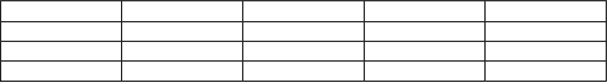
The Customer shall list below' specific services or billing account numbers for which (a) and/or (b) above do not apply and therefore should be assessed FUSF Surcharges:

FEDERAL UNIVERSE SERVICE FUND ANNUAE CERTIFICATION FORM 2026 CERTIFICATION FORM’

- . FOR NON—U.S. CARRIERS

The Customer hereby certifies exemption from FUSF contributions for ALL purchased services because at least one of the following applies:

  - Customer is a foreign carrier that is purchasing telecommunications services only to provide non- U.S. telecommunications services that originate outside of the U.S . but terminate in the U.S. for which all revenues are from non-U.S . end users.
 Customer is a foreign carrier that is purchasing telecommunications services only to provide international telecommunications services that either originate or terminate in the U.S. for which all revenues are from U.S. resellers that Customer has a reasonable expectation contribute directly to the federal universal service support mechanisms on the assessable portion of revenues from offerings that incorporate the purchased services.
 Customer is a foreign carrier that is purchasing telecommunications services only to provide services that traverse the U.S. (i.e., non-domestic services that both originate and terminate outside of the U.S. but are routed through the U.S .). Customer certifies that it is not required to obtain an FCC Form 499 filer ID, file quarterly or annual Form 499 reports, or contribute to the federal Universal Service Fund.
The Customer has an obligation to promptly update the information provided in this certification form. If at any time the Customer’s certifications as contained herein are no longer accurate, the Customer shall, no later than thirty (30) calendar days of the change, complete and submit to Meratalk LLC updated certification form and any other required documentation.
For future services purchased from Meratalk LLC after the date identified below on this certification form, Customer certifies that the new services will be treated in the same manner as the existing service(s) as certified to on this form, until Customer submits an amended form. If any new services purchased after the date of this certification form should be assessed FUSF Surcharges, Customs is Obligated to notify Meratalk LLC and specify the BANs that are FUSF- assessable.
If the information provided by the Customer in this certification form or any updated certification, 1s at any time determined to be incorrect or if it changes and the Customer does not notify Meratalk LLC as required, Meratalk LLC reserves the right to pursue all available remedies, it Find’s but not limited to imposing any FUSF Surcharges and other taxes and surcharges applicable to the services provided by Meratalk LLC Late- payment interest and/or penalties. The Customer also agrees to indemnify and hold Meratalk LLC harmless from any claim or action resulting in Meratalk LLC reliance on the information provided by the Customer In this certification form.

The individual named below is authorized by the Customer to make this certification on its behalf. The undersigned authorized representative certifies that all statements above are true and accurate.

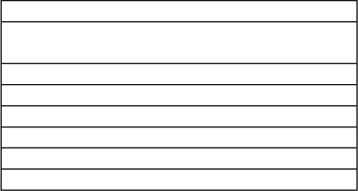
Full Legal Name of Customer or Affiliate:

Signature of Authorized Representative: Printed Name of Authorized Representative: Title of Authorized Representative:
Street Address:
CU, State Zip Code:
Phone Number and Email Address: Date:

